Introduction to LINGO

Overview
LINGO is a program for solving general optimization problems, including linear programs, integer programs, nonlinear programs (NLP), and stochastic programs. Nonconvex NLP’s can be solved with the built-in Global solver. It contains a built-in user manual that can be accessed from the LINGO menu: Help| Help Topics| Contents| LINGO14.0 User’s Manual.

Installation
You can download the latest “student” PC version of LINGO from: http://www.lindo.com.
When downloading it, note the directory into which it was downloaded. You install it by running the setup.exe file that was downloaded into this directory. . Installation takes about one minute.

Quick Usage
Appendix 3.1 in the text provides a good introduction to using LINGO. The best way to become familiar with LINGO is to apply it to some of the examples included on the CD-ROM. The following screen shot illustrates some of LINGO’s style.

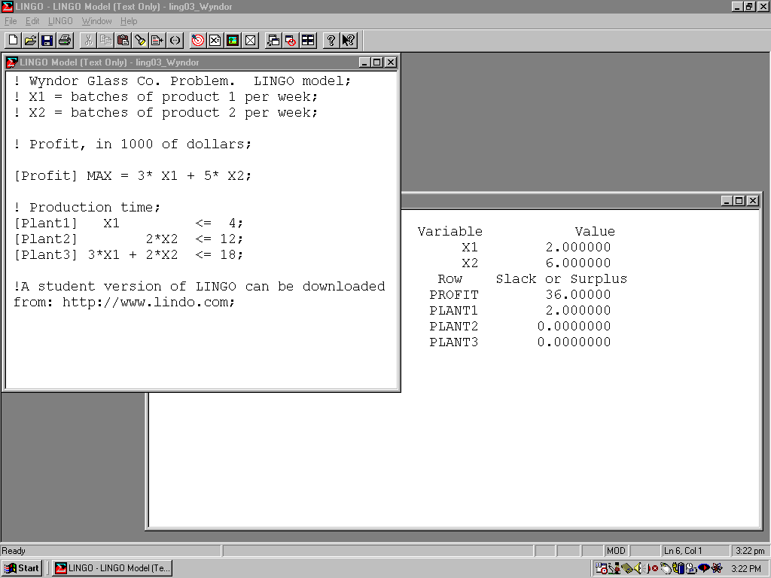

Models can be retrieved from and saved to files using the “File” menu item on the upper left.

Models, such as the Wyndor Glass problem, can be edited in a model window using the “Edit menu item that is second from the left at the top.

A model is solved by clicking on the red “bullseye” menu item on the tool bar at the top.

Solving a model does not automatically generate a solution report. Clicking on the “X=” menu item just to the right of the bullseye will generate a solution report window as seen above.

Distinctive and Advanced Features

Sets for Large Models. LINGO allows powerful set-based statements that allow you to create very large planning models with just a few statements. In contrast to spreadsheets, a set in LINGO may have more than two dimensions, so it is easy to build models with dimensions such as suppliers, customers, products, time periods, etc. The set based capability allows you to build and test small models, which can then be easily scaled up to large practical problems by changing only the input data. There are none of the old spreadsheet limitations of at most 255 columns and at most 65536 rows, and restriction to two-dimensional arrays. You can find lots of examples that illustrate the various features of LINGO by perusing the MODELS library at www.lindo.com. Click on:
MODELS | Keywords index to see several hundred models arranged by topic.

Data Sources. It has very simple “hooks” that allow it to retrieve input data from and return results to spreadsheets, databases, and regular files.

Global Optimization. It has a Global Optimization capability that enables it to find guaranteed globally best solutions to nonconvex problems. Traditional optimizers may get stuck at a local optimum on such problems. The Global Optimizer recognizes most mathematical functions of interest, such as sin( ), cos( ), abs( ).

Planning Under Uncertainty. It has a Stochastic Programming capability that allows you to solve models in which certain parameters, such as demands or prices, are randomly chosen from specified probability distributions.

Multiple Models, Programming, and Procedures. For complicated practical applications you may want to solve multiple models in a “run”, using the output of one model as input to another model. LINGO allows CALC regions in which you can write standard programming statements to solve multiple models, call procedures, and write customized reports.

Easy to Use. For users who are familiar with the simple, easy to use features of LINDO for the past 30 years, the LINDO capability has been incorporated into LINGO. If you want LINGO to recognize the simpler LINDO syntax, you click on:
LINGO | Options | Interface | File Format | ltx(LINDO) | Apply | OK

Graphics. LINGO now has extensive graphics capabilities. Output from a model can be converted to a graph with just two or three statements. Some example graphs or charts are illustrated below.

Graphs of mathematical functions:

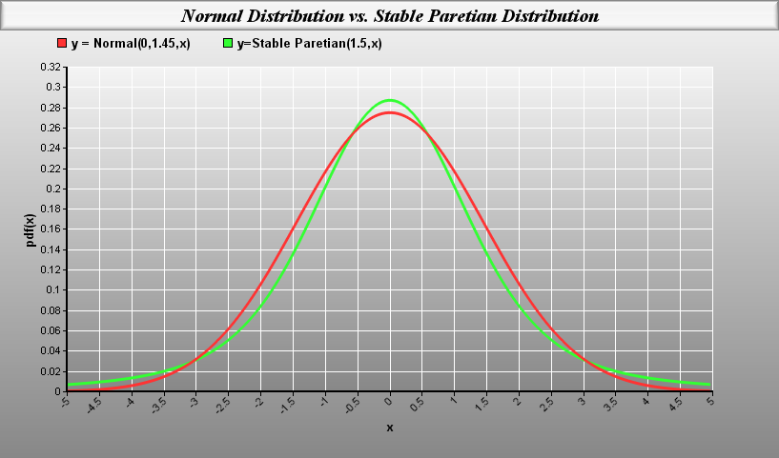

Graphs of mathematical functions in two dimensions:

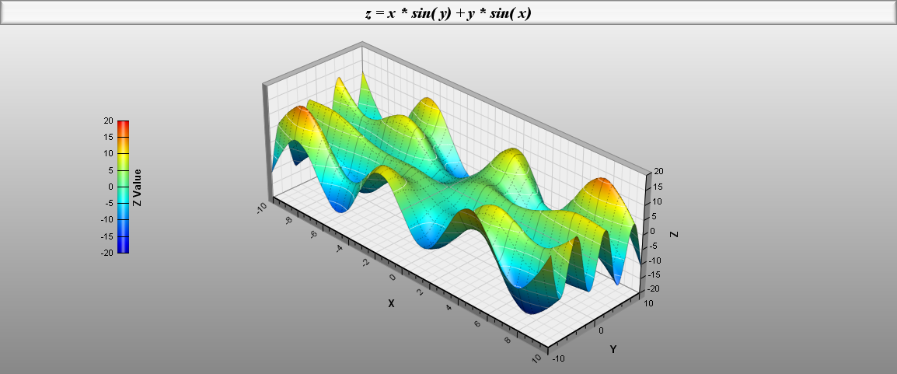

Graphs of networks:

