Introduction to What’sBest!

Overview
What’sBest! is an add-in for Excel that allows you to solve general optimization problems within the Excel spreadsheet environment. It is noted for its ability to solve large industrial optimization problems. It can solve all problem types: linear programs, integer programs, nonlinear programs (NLP), and stochastic programs. Nonconvex NLP’s can be solved with the built-in Global solver. It contains a built-in user manual that can be accessed by clicking on WhatsBest | Help

Installation
You can download the latest “student” PC version of What’sBest! from: http://www.lindo.com. Note the word size of your version of Excel, typically 64-bit. Make sure you download the version of What’sBest! consistent with your version of Excel. You install it by running the setup.exe file in the download package. Installation takes about one minute.

Quick Usage

If you have an existing “What If” spreadsheet model, you can convert it to a “What’sBest” optimization model using the menu bar below.

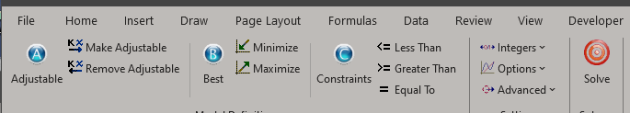

You follow the three ABC’s of WB:

A) Adjustable cells are identified by highlighting them with the cursor and then clicking on “Make Adjustable” on the menu bar.

B) The Best cell, to minimized or maximized, it highlighted with the cursor and then one clicks on either Minimize or Maximize.

C) Constraints are specified by placing the cursor between two cells for which you want to specify a relationship, and then click on either Less Than, Greater Than, or Equal To.

Distinctive and Advanced Features

Global Optimization. It has a Global Optimization capability that enables it to find guaranteed globally best solutions to nonconvex problems. Traditional optimizers may get stuck at a local optimum on such problems. The Global Optimizer recognizes most mathematical functions of interest, such as sin( ), cos( ), abs( ).

Planning Under Uncertainty. It has a Stochastic Programming capability that allows you to solve models in which certain parameters, such as demands or prices, are randomly chosen from specified probability distributions.

